React Js Resources
Redux
Yoshita Jain
https://youtu.be/CEHciMNpaC4?list=PLp18NAIKHWnuq1ODXRD-3ivVJ3R89A5UL
Great stack
Yoshita jain – react playlist
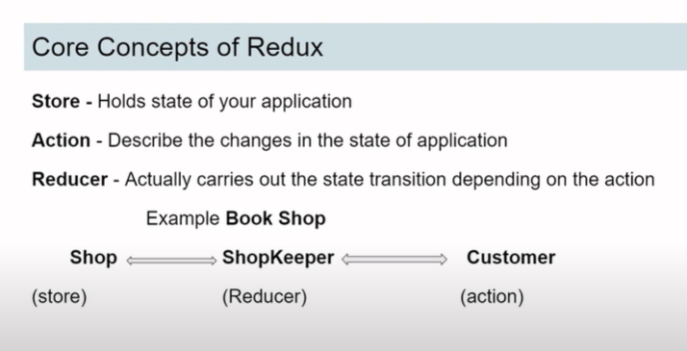

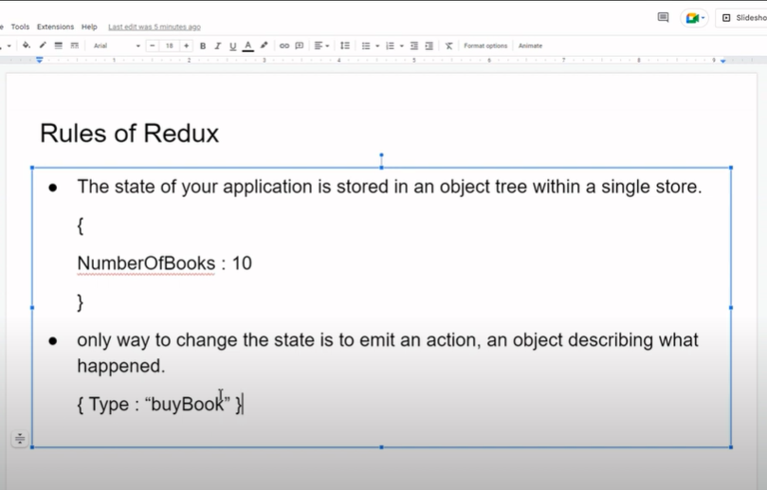

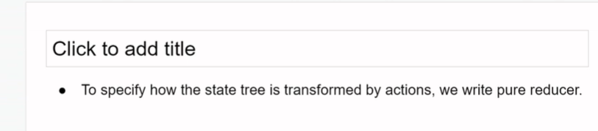

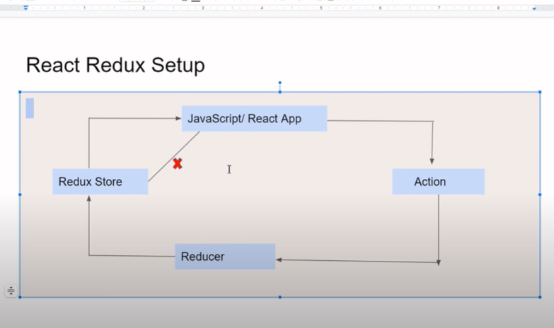
Kya krna hai – action
Kaise krna hai – reducer

Npm I react redux

Action
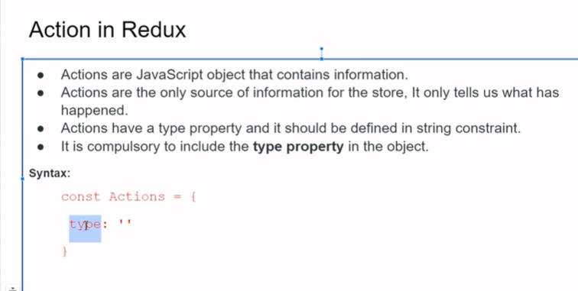

bookAction.js
import {buybook} from ‘./Booktype.js’;
const purchase_book = () => {
return {
type : buy_book
}
}

bookType .js
export const buy_book = “buy_book”

Reducer

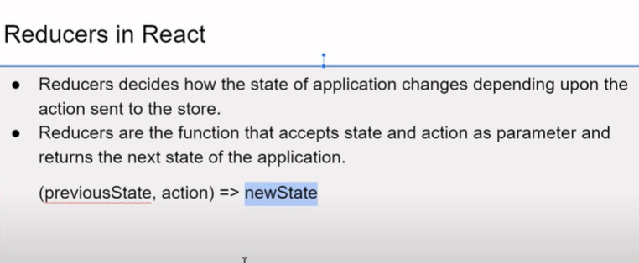
Parameter 1. State, 2. Action
State -
reducer ek function hota hai wo two parameter accept krta hai , 1. State, 2. Action
State – initial state or jo bhi hamara initial state hai wo accept krta hai
Action – es state ko kis tarike se change krna hai , and after changing that hume jo new state hai wo return krta hai

BookReducer.js
import {buy_book} from ‘./bookType’;
const initialState = {
Number of book : 20
}
const BookReducer = (state = intialState, action) => {
switch(action.type){
case buy_book : return {
…state, NumberOfBooks : state. state.NumberOfBooks - 1 }
}
Default : return state
}
Export default BookReducer;

Redux
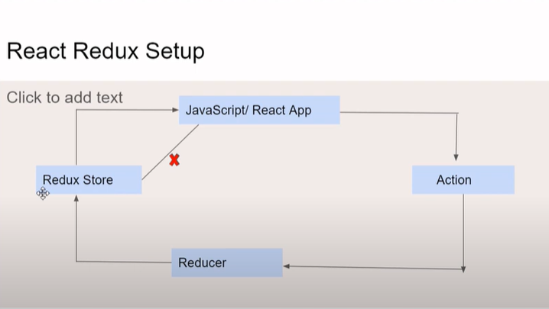
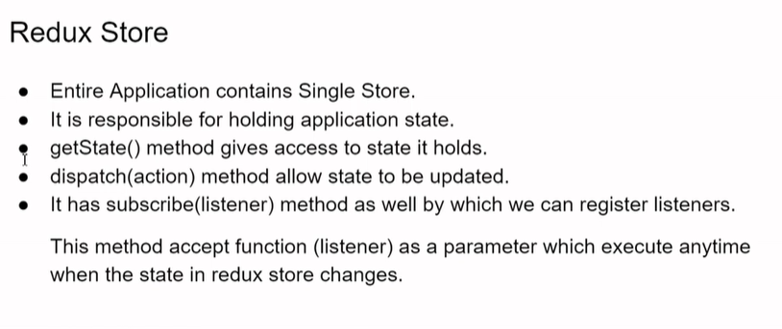Store.js
Import {createStore } from ‘redux’;
Import BookReducer from ‘./BookReducer’
const Store = createStore(BookReducer);
export default Store;

App.js
Import {Provider} from ‘react-redux’;
Import Store from ‘reduxContainer/Store’;
const App() {
return (
< Provider store = {store} >
<h1>store</h1>
<BookContainer />
< Provider >

)
}
export defau
ly App;
useSelector
useSelecter hook jo hai function accept krta hai
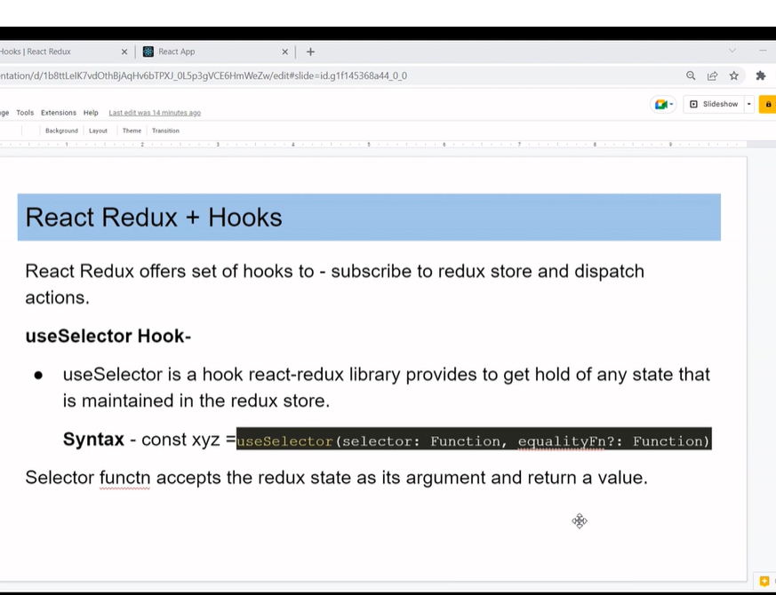
BookContainer.js
const BookContainer(){
Const numberOfBook = useSelector(state => state.numberofbbok)
return (
<h1>Book Container</h1>
{numberofbook}
)
}
Export default BookContainer;
useDistach
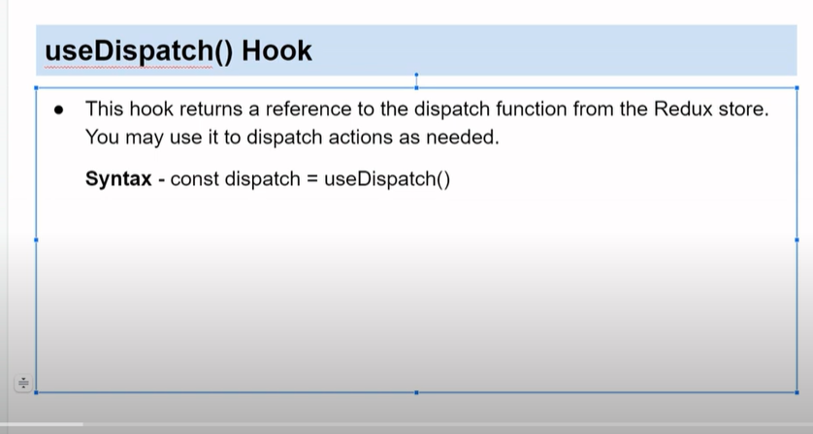

Initial state – state ko update krne ke liye – useDispatch()
useDispatch hook jo hota hai , hume return krta hai, dispatch function ka reference
action ko dispatch krenge
import purchase_book from ‘./purchase_book’
const dispatch = useDispatch();
<button onClick = {() => (dispatch(purchase_book))}>buy book </button>
@@@@@@@@@@@@@@@@@@@@@@@@@@@@@@@@@@@
Code Volution
React redux
https://youtu.be/9boMnm5X9ak?si=13t_C-CqsYj9eHUc
redux store state of our application
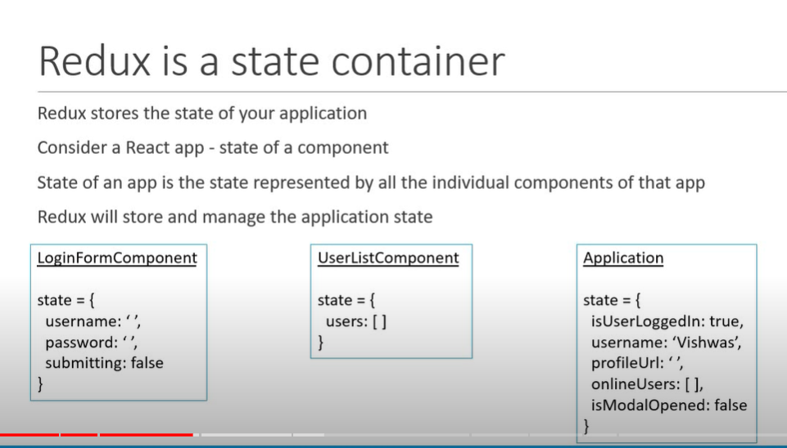

Redux-demo-folder
npm I
Npm I redux
Index.js
three core concepts
cake shop
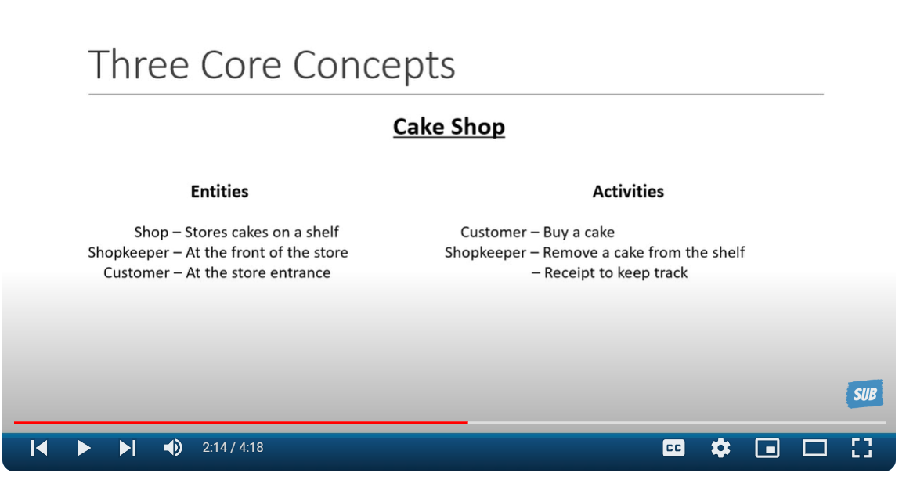
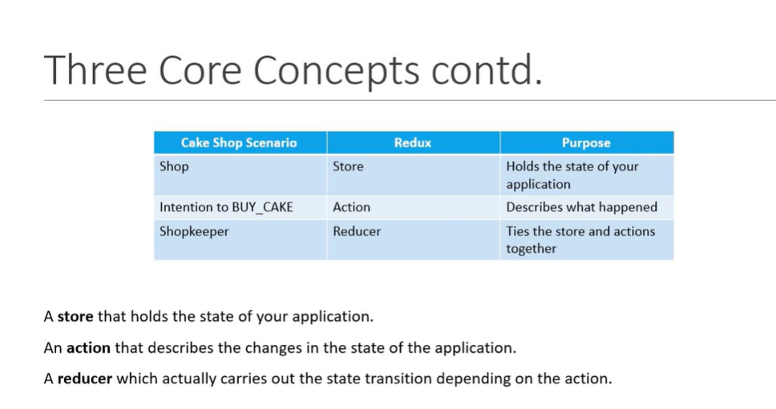

Action
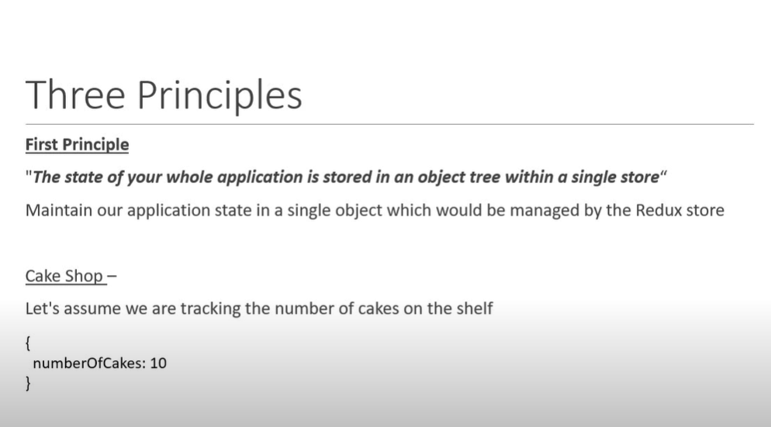
Action
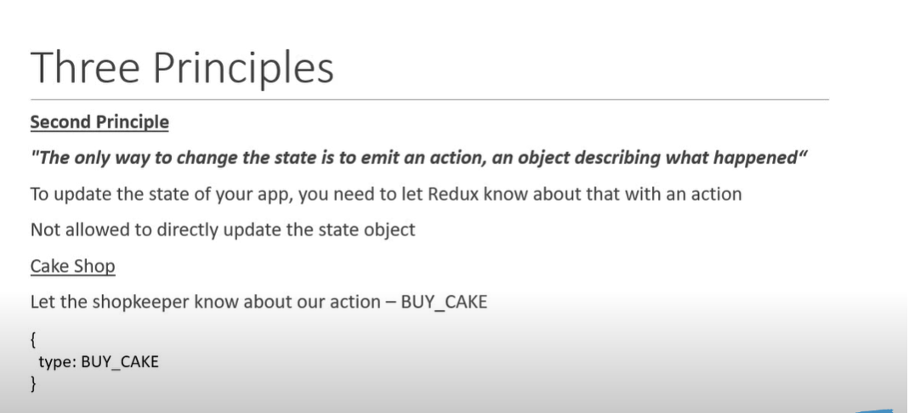
Reducer
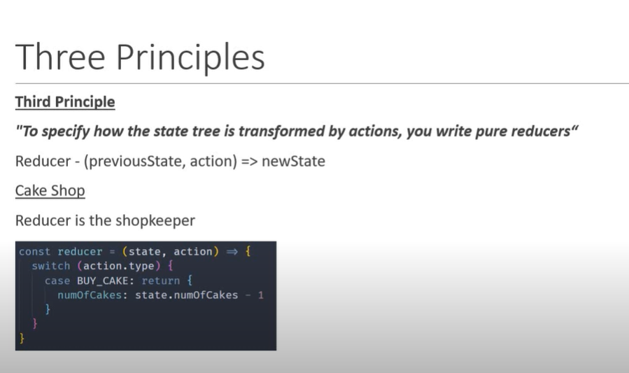
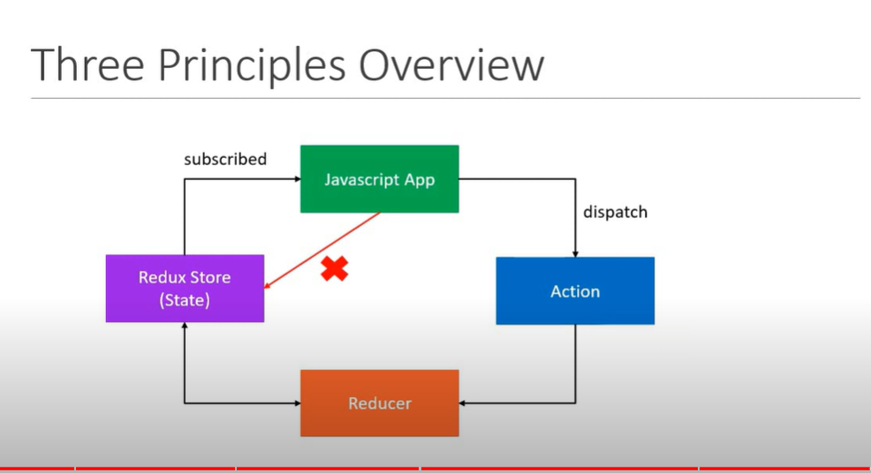

Actions
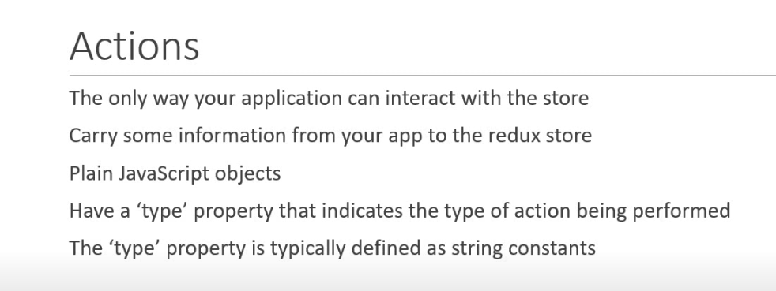
Action is an object it has object property
Action is a function which return object
Action is an object with type property
and action creater is a function that return an action
Index.js
Const BUY_CAKE = “BUY_Cake”
Const buy_cake () {
return {
type : BUY_CAKE,
info : ‘first redux action’
}
}

Reducer
Reducer - reducer updated the state based on action
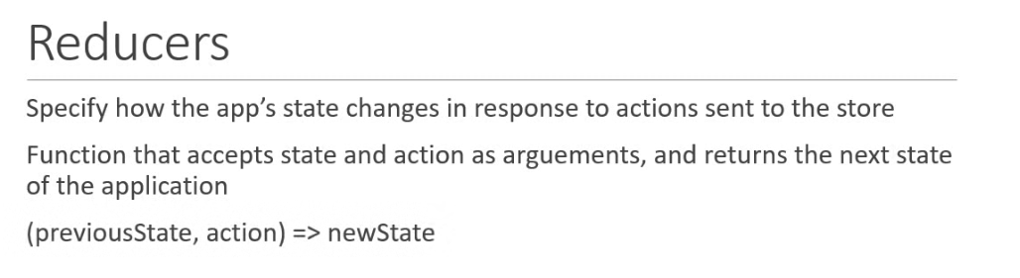
const intialState = {
numOfCakes : 10
}
const reducer = (state = initialState, action) => {
switch(action.type){
case BUY_CAKE : return {
…state. numOfCakes : state.numOfCakes-1
}
default : return state
}
}

Store
subscribe method (useSelecter) accept function as a parameter
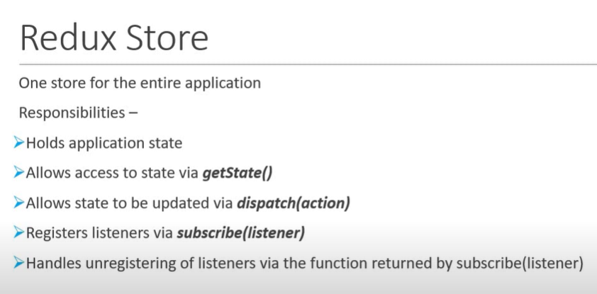
const createStore = redux.createStore;
const store = createStore(reducer);
const unsubscribe = Store.subscribe(() => console.log(‘updated state’, store.getState()));
store.dispatch(buycake());
unsubscribe();
Cakes and Ice Cream
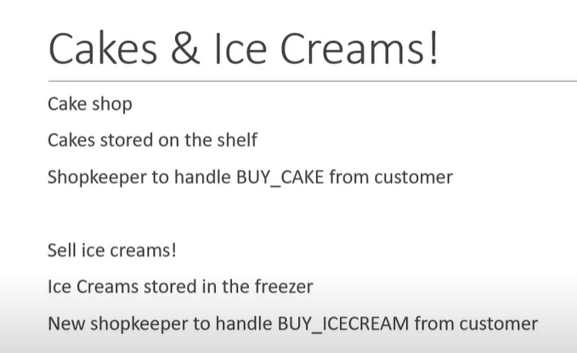
Multiple Reducers
const initialState = {
numOfCakes : 10,
numOfIceCream : 20
}
const reducer = (state = initialState, action) => {
switch(action.type){
case BUY_CAKE : return {
…state, numOfCakes : state.numOfCakes-1
}
case BUY_ICECREAM : return {
…state, numOfIceCream : state. numOfIceCream -1
}

default : return state
}
}
we need to define action and action creater for BUY_ICECREAM
const BUY_ICECREAM = “BUY_ICECREAM”;
function buyIceCream(){
return {
type : BUY_ICECREAM
}
}
store.dispatch(buyIceCream());

Other approach to use – useReducer
split the state and reduer
instead of having one object for initial state now we are going to have two
Const initialCakeState = {
numOfCake : 20;
}

Const initialIceCreamState = {
numberOfIceCream : 30
}

Different reducer for cake and icecream
const CakeReducer = (state = initialState, action) => {
switch(action.type){
case BUY_CAKE : return {
…state. numOfCakes : state.numOfCakes-1
}
default : return state
}
}
const IceCreamReducer = (state = initialState, action) => {
switch(action.type){
case Ice_Cream : return {
…state. numOfIceCream : state.numOfIceCream-1
}
default : return state
}
}
Combine Multiple Reducer
const combineReducers = redux.combineReducers;
const rootReducers = combineReducers({
cake : cakeReducer,
IceCream : IceCreamReducer
});
store
const store = createStore(rootReducers);
Middleware

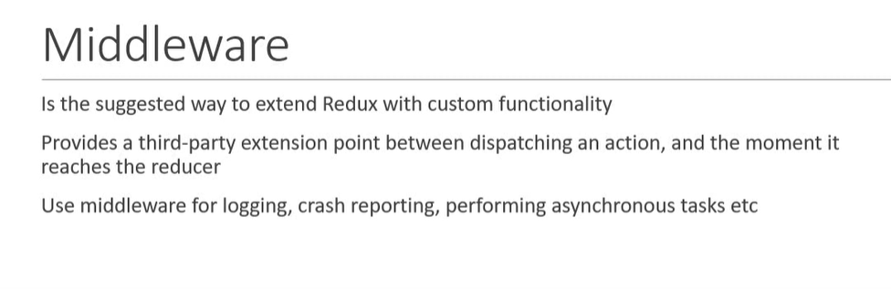
@@@@@@@@@@@@@@@@@@@@@@@@@@@@@@@@@@@@@@@@@@@@@@@@@@@@@@@@@@@@@@@@@@@@@@@@@@@@@@@@@@@@@@@@@@
redux ToolKit Tutorials
Thapa technical
https://youtu.be/DXlnr7rDDR0?si=jMv4S5Aww5Ar-G_1
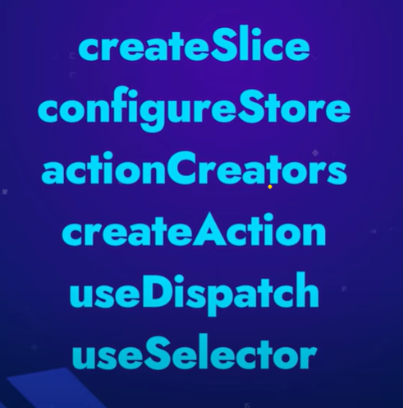

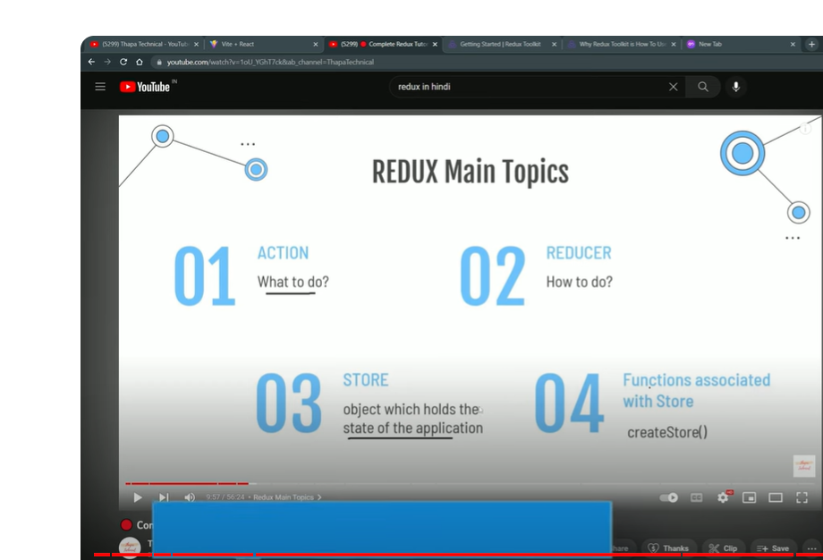
Redux
yoshita jain
codevolution
Thapa technical – toolkit
chai with code
Patel mern stack – toolkit
code step by step – revision|
chai with code
middleware
redux thunk
redux saga
payload

Chai with code
https://youtu.be/1i04-A7kfFI?si=4gG0vFgk9P4R161J
Redux devtool extensions
store
reducer
useselecter
useDispatch
npm create vite@latest
npm run dev
https://redux-toolkit.js.org/introduction/getting-started
npm install @reduxjs/toolkit
npm install react-redux
What's Included​
Redux Toolkit includes these APIs:
- configureStore(): wraps createStore to provide simplified configuration options and good defaults. It can automatically combine your slice reducers, adds whatever Redux middleware you supply, includes redux-thunk by default, and enables use of the Redux DevTools Extension.
- createReducer(): that lets you supply a lookup table of action types to case reducer functions, rather than writing switch statements. In addition, it automatically uses the immer library to let you write simpler immutable updates with normal mutative code, like state.todos[3].completed = true.
- createAction(): generates an action creator function for the given action type string.
- createSlice(): accepts an object of reducer functions, a slice name, and an initial state value, and automatically generates a slice reducer with corresponding action creators and action types.
- combineSlices(): combines multiple slices into a single reducer, and allows "lazy loading" of slices after initialisation.
- createAsyncThunk: accepts an action type string and a function that returns a promise, and generates a thunk that dispatches pending/fulfilled/rejected action types based on that promise
- createEntityAdapter: generates a set of reusable reducers and selectors to manage normalized data in the store
- The createSelector utility from the Reselect library, re-exported for ease of use.
example

@@@@@@@@@@@@@@@@@@@@@@@@@@@@@@@@@@@@
Great content!
https://github.com/codebucks27/React-Redux-Todo-App

if we are learning redux toolkit then do we also need to learn redux thunk???????????????????

When learning Redux Toolkit, you don’t necessarily need to learn Redux Thunk separately. Redux Toolkit includes built-in support for Redux Thunk, which simplifies handling asynchronous actions. This means you can use thunks directly within Redux Toolkit without needing additional setup¹².
Redux Toolkit also offers other features like createAsyncThunk, which further simplifies working with asynchronous logic¹. So, focusing on Redux Toolkit should cover your needs for managing async actions effectively.
Are you working on a specific project where you’re planning to use Redux Toolkit?

if we are learning redux toolkit then do we also need to learn redux saga????????

If you’re learning Redux Toolkit, you don’t necessarily need to learn Redux Saga as well. Redux Toolkit includes Redux Thunk by default, which is sufficient for handling most asynchronous operations in simpler applications¹².
However, Redux Saga can be beneficial if your application requires more complex asynchronous flows or side effects. Redux Saga uses generator functions, which provide more control and flexibility over handling side effects compared to thunks³⁴.
In summary:
- Redux Toolkit with Thunk: Great for simpler, straightforward asynchronous tasks.
- Redux Saga: Ideal for more complex, large-scale applications with intricate side effect management.
It really depends on the complexity of your project and your specific needs. Do you have a particular project in mind that you’re working on?

